CIS 276 -- Exercise 3a

Create a folder hierarchy like the one demonstrated in class:

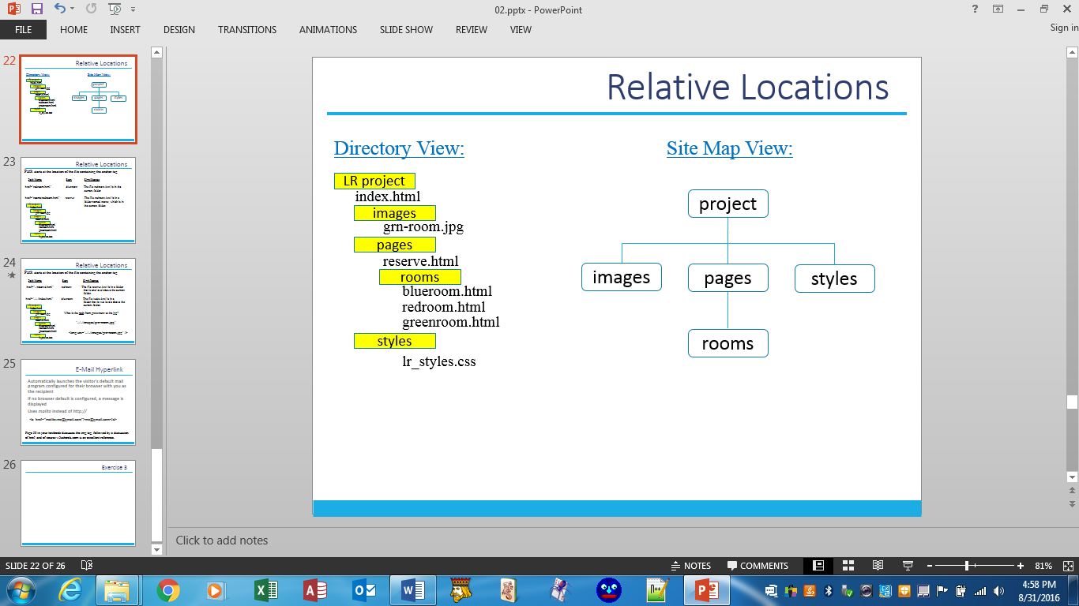

Oops, you have 3 image files not 1.

The files to be placed in the various folders have been provided on the classroom N: drive and should be copy/pasted into your hierarchy.

After that step is completed, add a <nav> section to EACH of the pages with hyperlinks to make navigation a seamless process throughout the site. From any and all pages, one should be able to hyperlink to Home, Blueroom, Redroom, Greenroom, Reservations, and Get Directions (your choice of a map app). In addition, each page for the 3 rooms should have an appropriate image.

Exercise 3b

In previous exercises, you created pages for Universal Box. Put them all together as a unified web site.

Your first step will be to create a folder hierarchy with the project (universalBox) at the highest level. Images, Pages, and Styles will be your only other folders for this project. Nothing will be placed in the Styles folder. In the Images folder, copy/paste the three image files you have been provided. The Pages folder should contain all of the "final" pages you have created for Universal Box (tours, custom, orders, and index). Remember to place the index file in the project folder.

Now it's time for you to start making decisions about how your web site should look and function. So you decide where to place the *logo* and *pres* images in the *index* page and where to place the *bldg* image in the *tours* page. In addition, you decide what navigation should be provided. I realize you can't give your site too much style until we get into CSS, but you can provide function.